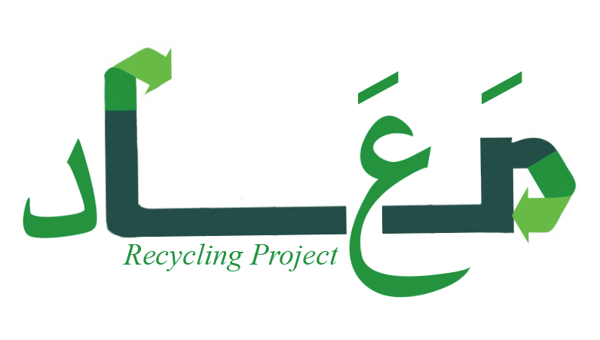**Ma’ad’s Website**

**Atheer Almogbil**

* **Description:**

Ma’ad is a recycling initiative started by students from the CIS department at Prince Sultan University. This project was born in a project management class taught by Ms. Nafla AlKahtani.

Ma’ad aims to enhance the College of Women at Prince Sultan University by making it environmentally active and going green by recycling paper, plastic, metals, and e-waste. It involves different parties including the maintenance office. Ma’ad will be implemented in all departments of the female campus in Prince Sultan University, encompassing all three buildings and a total of 169 offices, 13 of which are administrative offices. After which, Ma’ad will launch on a fuller scale, including the male campus.

* **Website Goals:**

Ma’ad’s official website will be a source of information in which internal and external sectors can learn about the initiative, the components of Ma’ad, how it works, and further details regarding the project. It can also work as a means of awareness in which videos, images, and other informative media can be used to help people understand why, what, and how to recycle. For instance, there can be a list of reasons on why Saudi Arabia should start recycling, or the correct bins to use to recycle paper, cups, bottles, etc.

* **Elements to be Used: *tentative to change**

<img>

<table>

<li>

<span>

<div>

<ol>

<a>

<p>

<ul>

<h1> <h2> ..

<br>

<link>

<meta>

<style>

<title>

* **WireFrame**

